**Day 5- Introduction to CSS**

https://lh6.googleusercontent.com/pzfkpYzj_xNKuCIRaMdGOcJRGHimowNa5u7Ned4rI9rrL8AGediPxVgoTzYM65B3F7T2wKnzzs4NN42aMrsGf_ZZvSDkx9V2RHZ5SJ6YjjldEA7E9x9SwUSXZmLWBKV9rfHuNRbkG3bXpFexSg

**Refresh Yesterday’s Class-10 Minutes**

**Lecture-20 Minutes**

**What is CSS?**

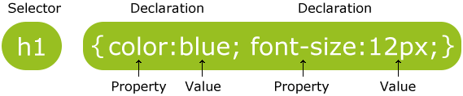

**CSS Selectors**

* **Element Selector**
* **Id Selector**
* **Class Selector**
* **Grouping Selector**

**CSS Comments**

**Activity based on above lecture-30 Minutes**

**How to Insert CSS (3 Ways)-20 Minutes**

* **Inline** - by using the style attribute in HTML elements
* **Internal** - by using a <style> element in the <head> section
* **External** - by using an external CSS file

**Activity based on above lecture-40 Minutes**

**Activity based on today’s class-1 Hour**